

Tribhuvan University
Faculty of Humanities and Social Science

INTERNSHIP REPORT
ON
GARG-DENTAL E-COMMERCE WEB APP

Submitted To
Department of Information Technology
Kathford International College of Engineering and Management
In partial fulfillment of the requirement for the Bachelor Degree in Computer Application

Submitted By
Prakash Pathak
Roll No: 45602131
TU Reg:- 6-2-456-63-2022

Under the Supervision of
Ms. Sarita Neupane

July, 2026

ACKNOWLEDGEMENT
I would like to express my sincere gratitude to Global Tech Nepal Pvt. Ltd., for providing me with the opportunity to undertake my internship in a professional and innovative working environment. I am thankful to the management and technical staff, especially the Software Engineering Unit, for their continuous support, guidance, and for allowing me to gain valuable hands-on experience in real-world software development. Working alongside experienced engineers provided me with practical insights into large-scale production architectures, agile development methodologies, continuous testing practices, and modern web application development. I would also like to extend my special appreciation to my industrial project mentor for the valuable code reviews, technical guidance, and mentorship throughout the internship, which significantly contributed to my professional growth.
I would also like to express my heartfelt appreciation to the Department of Information Technology, Kathford International College of Engineering and Management, for providing a strong academic foundation, quality education, and a supportive learning environment. The knowledge, practical training, and resources offered by the department played a vital role in preparing me for the challenges of the professional software engineering industry.
I am deeply grateful to my academic supervisor, Ms. Sarita Neupane, for her valuable guidance, continuous encouragement, and constructive feedback throughout the preparation and evaluation of this internship report. Her academic insights, thoughtful suggestions, and constant support greatly contributed to the successful completion of this work and further strengthened my understanding of software engineering principles.
Finally, I would like to express my sincere thanks to my friends, classmates, and family for their unwavering encouragement, patience, and moral support throughout my internship period. Their motivation and understanding helped me remain focused and committed to achieving my learning objectives and successfully completing this internship.

ABSTRACT
This internship provides a detailed overview of the technical activities, software development methodologies, and engineering outcomes completed during the first 10 weeks of a 12-week industrial internship as a Full Stack Developer Intern at Global Tech Nepal Pvt. Ltd., Teku, Kathmandu. The core mandate of this industrial placement involves designing and executing two production-grade, full-stack e-commerce platforms: GargDental and NityaGro. GargDental is an e-commerce ecosystem optimized for a dental clinic to manage and sell medical tools, clinical dental instruments, and sterilization consumables. NityaGro is a consumer-centric e-commerce retail platform dedicated to marketing healthy, pure organic kitchen foods, including whole spices, organic jaggery powder, and premium cold-pressed cooking oils. Both production architectures are built with modern web technologies, using Next.js for front-end interface engineering and server-rendered data structures, Next.js API Routing for handling backend services, Prisma ORM as the database layer mapping to a MySQL engine, and safe JSON Web Tokens (JWT) for stateless session authentication. Figma was used for user experience wireframing and prototyping, while Postman served as the validation engine for integration testing. This report highlights the system design, relational data structures, weekly technical achievements, and lessons learned in shifting from monolithic application architectures to efficient, hybrid-rendered server ecosystems within an Agile team structure.
KEYWORDS: Next.js, Full Stack Development, Prisma ORM, MySQL, JWT Authentication, GargDental, NityaGro, E-Commerce, Hybrid Rendering.
TABLE OF CONTENTS
ACKNOWLEDGEMENT i
ABSTRACT ii
LIST OF ABBREVIATIONS v
LIST OF FIGURES vi
LIST OF TABLE vii
CHAPTER-1: INTRODUCTION 1
1.1. Introduction 1
1.2. Problem Statement 1
1.3. Objectives 2
1.4. Scope and Limitation: 2
1.4.1. Scope 2
1.4.2 Limitations 3
1.5. Report Organization 4
CHAPTER 2: INTRODUCTION TO ORGANIZATION 5
2.1. Organization Details 5
2.2. Organization Hierarchy 6
2.3. Working Domains of Organization 7
2.4. Description of Intern Department/Unit 7
CHAPTER 3: BACKGROUND STUDY AND LITERATURE REVIEW 9
3.1. Background Study 9
3.2. Literature Review / Related Works 10
CHAPTER 4: INTERNSHIP ACTIVITIES 12
4.1. Roles and Responsibilities 12
4.2. Weekly Log (Technical Details of Activities) 12
4.3. Description of the Project(s) Involved During Internship 13
4.4. Tasks / Activities Performed 16
CHAPTER 5: CONCLUSION AND LEARNING OUTCOMES 19
5.1. Conclusion 19
REFERENCES 20
APPENDIX 21

LIST OF ABBREVIATIONS
API : Application Programming Interface
BCA : Bachelor in Computer Applications
B2C / B2B : Business-to-Consumer / Business-to-Business
CSR : Client-Side Rendering
CRUD : Create, Read, Update, Delete
CSS : Cascading Style Sheets
IDE : Integrated Development Environment
ISR : Incremental Static Regeneration
JWT : JSON Web Token
MVT / MVC : Model-View-Template / Model-View-Controller
ORM : Object-Relational Mapping
SEO : Search Engine Optimization
SPA : Single Page Application
SSR : Server-Side Rendering
UI / UX : User Interface / User Experience

LIST OF FIGURES
Figure 1: Company Logo of Global Tech Nepal 5
Figure 2: Organization Hierarchy of Global Tech Nepal 6
Figure 3: Garg Dental Landing Page 15
Figure 4: Nityagro Landing Page 16
Figure 5: Next.js MVC Design Pattern Architecture 17

LIST OF TABLE
Table 1: Contact Details of Global Tech Nepal Pvt. Ltd 6
Table 2: Author's Internship Duration 8
Table 3: Weekly Activity Log 12

CHAPTER-1: INTRODUCTION

1.1. Introduction
This internship report presents the comprehensive industrial work, software engineering methodologies, and systems development executed during a 12-week internship at Global Tech Nepal Pvt. Ltd., located in Teku, Kathmandu. As a Full Stack Developer Intern specializing in the Next.js framework, the past 10 weeks have been dedicated to designing, building, and optimizing modern full-stack web applications.
The core of the industrial training involved working on two distinct production-grade e-commerce ecosystems: GargDental (a specialized dental clinic and medical equipment e-commerce application) and NityaGro (an organic kitchen products e-commerce application dealing in items such as spices, jaggery powder, and premium cold-pressed cooking oils).
This report highlights the engineering paradigms applied to solve complex architectural challenges, bridges advanced computer science theories with corporate software development workflows, and details how modern tools like Next.js Server Actions/API routes, Prisma Object-Relational Mapping (ORM), MySQL, and secure JSON Web Token (JWT) authentication were integrated into production-ready software systems.

1.2. Problem Statement
Traditional e-commerce architectures face critical friction points in modern web ecosystems. Single Page Applications (SPAs) built with purely client-side rendering (CSR) models often suffer from poor Search Engine Optimization (SEO) because search engine web crawlers scrape empty HTML pages before JavaScript execution is complete. Furthermore, slow initial page loads (high Time to Interactive) negatively impact conversion rates. Conversely, traditional multi-page application servers create excessive server overhead by rebuilding complete pages on every dynamic interaction.
For the two specific target systems assigned during this internship, the technical challenges were highly contextualized:
store owners to efficiently manage products, orders, and customer interactions. This improves operational efficiency, customer satisfaction, and overall sales.
- GargDental: Dental clinics and medical professionals require highly secure, rapid filtering systems for specialized equipment, along with interactive clinic-oriented features. Traditional e-commerce setups do not handle the complex data parameters required for medical-grade products seamlessly.
- NityaGro: An organic food retail store relies heavily on dynamic imagery, changing inventories (batches of organic crops, shelf life metrics), and highly localized organic SEO to rank effectively on search engines.
Both applications required a structural design capable of serving dynamic relational product tables, preserving transactional integrity during checkout routines, preventing unauthorized administrative data injections, and running performant client states—all within a single unified framework.

1.3. Objectives
The primary objectives of this internship are:
• To gain industry experience in full stack development using Next.js, enhancing skills in responsive design, API integration, and secure backend workflows.
• To design and develop a responsive e-commerce platform that delivers smooth shopping experiences across different devices and platforms.

1.4. Scope and Limitation:

1.4.1. Scope
The scope of this industrial placement focused on the end-to-end development, testing, and implementation stages of an e-commerce platform. The specific boundaries of work performed include:
- Front-End Engineering: Developing fully responsive user interfaces using utility classes and responsive grids to ensure seamless adaptability across varying desktop, tablet, and mobile viewports.
- Back-End Architecture: Constructing the logical business handlers, data processing functions, and endpoint patterns required to decouple data fetching from display pipelines.
- Database Management: Defining entity relationships, updating tables using migration tools, and writing optimal search and retrieval configurations inside a relational database engine.
- Administrative Control Panels: Designing functional administration interfaces to support structured CRUD (Create, Read, Update, Delete) actions for inventory tracking, categorization trees, and customer orders.
- System Testing and Validation: Executing route checks, form boundary validation, and secure session confirmation protocols locally to minimize integration vulnerabilities.

1.4.2 Limitations
Due to time constraints, security compliance boundaries, and the localized nature of the development environment, the following limitations apply:
- Local Database Limitations: Primary system development and local testing utilized lightweight relational databases, which lack the massive parallel parsing and clustering properties required for enterprise-scale transaction loads.
- Simulated Financial Environments: Due to institutional compliance policies, live online payment provider networks were not permanently activated; checkout processes use simulated "Cash on Delivery" or mock-success response triggers.
- Absence of Cloud Orchestration: The systems were designed, tested, and validated within local hosting profiles (localhost). Deploying multi-container clusters, load-balancing components, and live cloud infrastructure was outside the immediate internship timeline.
- Local Asset Storage Constraints: Static and media files, such as high-resolution product inventory graphics, are served out of the application's local directory trees rather than using cloud-managed object storage or distributed Content Delivery Networks (CDNs).

1.5. Report Organization
This report is organized into five chapters to provide a systematic overview of the project: Chapter 1: Introduction – Presents the project overview, problem statement, objectives, scope, limitations, and development methodology.
Chapter 2: Introduction to Organization – Details the corporate operating structures, engineering units, team reporting hierarchies, and divisional focus lines of the host agency.
Chapter 3: Background Study and Literature Review – Discusses relevant software engineering theories, database paradigms, and comparative literature assessments related to high-efficiency web applications.
Chapter 4: Internship Activities – Details my explicit roles, the complete chronological weekly log, foundational system blueprints, relational data mappings, and testing operations completed.
Chapter 5: Conclusion – Summarizes project achievements, technical knowledge gained, challenges resolved, and future scalability paths.

CHAPTER 2: INTRODUCTION TO ORGANIZATION

2.1. Organization Details
Company Overview
Global Tech Nepal Pvt. Ltd. is a technology solutions provider specializing in web development, software engineering, IT consulting, OMS (Order Management System) solutions, and accounting software services. The company focuses on delivering scalable, innovative, and user-centric software platforms that help businesses streamline operations, improve efficiency, and enhance overall productivity across various industries.

Figure 1: Company Logo of Global Tech Nepal
Global Presence: Global Tech Nepal Pvt. Ltd. operates with its headquarters in Kathmandu, Nepal, and has established collaborations and client networks across South Asia and international markets. The company serves clients in diverse industries, including healthcare, retail, and technology, delivering web and software solutions to businesses in Nepal, India, and other regions. Its growing partnerships and project deployments highlight its expanding footprint in the global IT services.
Mission Focus: To deliver scalable, innovative, and user-centric digital solutions across diverse industries. Global Tech Nepal Pvt. Ltd. specializes in web and software development, IT consulting, and full stack application engineering. The company emphasizes modern development practices, ensuring secure, responsive, and high-performing platforms that empower businesses to embrace digital transformation. Its mission is to provide end-to-end technology services from custom web applications and enterprise solutions to e-commerce platforms and cloud-based systems enabling clients to achieve efficiency, growth, and global competitiveness.

Table 1: Contact Details of Global Tech Nepal Pvt. Ltd
Company Name | GlobalTech Solution Pvt. Ltd.
Contact Number | 01-5329949 / 52 / 82
Website | https://globaltechnepal.com
Founded | 2010
Head Office | Teku, Kathmandu, Nepal
Research and Development Centre | Teku, Kathmandu, Nepal
Industry | Information Technology Services / OMS Services
Type of Organization | IT Services and Software Development  Company

2.2. Organization Hierarchy
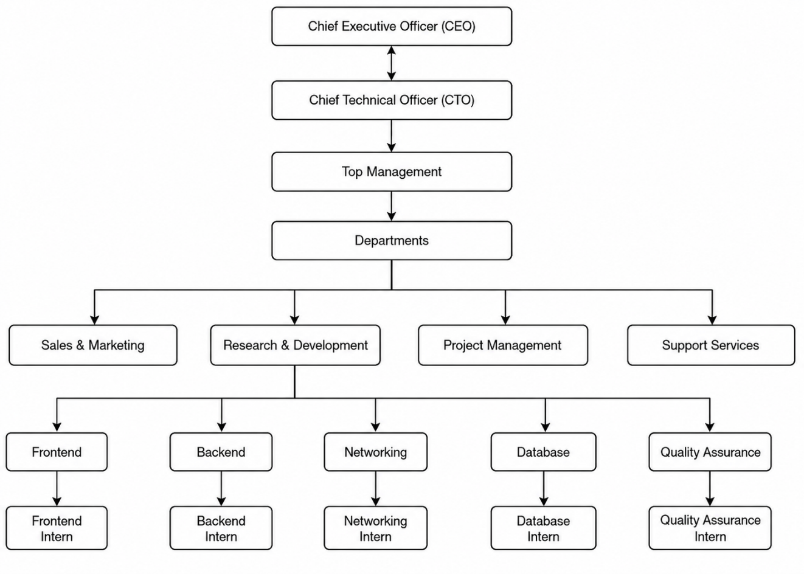
Figure 2: Organization Hierarchy of Global Tech Nepal

2.3. Working Domains of Organization
The core operations of the company span four primary engineering sub-sectors:
- Custom Enterprise Automation (ERP & CRM Systems): Building comprehensive resource planning and client management systems to optimize operational tracking for corporate clients.
- High-Throughput Web & E-Commerce Platforms: Architecting scalable digital marketplaces and web apps that handle secure data streams and high concurrent visitor traffic.
- Cross-Platform Mobile Application Design: Creating intuitive, natively optimized mobile experiences across iOS and Android ecosystems using single-codebase utility frameworks.
- Cloud Architecture and Data Operations: Transitioning legacy systems into cloud infrastructure while managing container orchestration pipelines.

2.4. Description of Intern Department/Unit
The internship placement was completed inside the Software Engineering Unit (Web Development Division). This unit specializes in using modern software languages, framework libraries, and object-relational mapping engines. The team works in two-week agile sprint blocks, holding morning status stand-ups, updating task boards, and enforcing strict code reviews via pull requests before changes can be merged into production branches.
Table 2: Author's Internship Duration
Particulars | Time
Start Date of Internship | 1st Baishakh, 2083
End Date of Internship | 32nd Asar, 2083
Total Duration | 3 Months
Office Hour | 10:00 AM – 6:00 PM
Working Hour | 8 Hours per Day
Working Days | 6 Days per Week
Holiday | Saturday

CHAPTER 3: BACKGROUND STUDY AND LITERATURE REVIEW

3.1. Background Study
Developing modular e-commerce platforms requires a strong baseline understanding of underlying modern web rendering models and database paradigms.
1. Rendering Paradigms: Client-Side vs. Server-Rendering Architectures
Traditional single-page web applications (SPAs) rely almost completely on Client-Side Rendering (CSR). In a CSR model, the server sends a minimal HTML shell along with a large JavaScript file. The client's browser must download, parse, and execute this file before rendering visible interface elements. While this provides smooth subsequent page transitions, it can cause long initial page load times and make search engine optimization (SEO) indexing difficult (Laudon, 2022).
Conversely, Server-Side Rendering (SSR) pre-renders web pages directly on the server host in response to a user request. The browser receives a fully compiled, human-readable HTML document, which reduces initial load times and ensures search engine scrapers can easily index the application's content.
2. Relational Database Modeling and Object-Relational Mappings (ORMs)
A stable e-commerce application relies on strong data integrity. Relational database engines organize data into structured tables using foreign key connections to prevent duplicate records and orphaned listings. Instead of writing raw, error-prone SQL strings inside application route files, modern web engineers use Object-Relational Mapping (ORM) software layers. An ORM provides a type-safe code interface that translates backend object models into optimized database tables, automating migrations and preventing database anomalies during application upgrades.
3. Stateless Token Authentication Mechanisms
Managing secure user identity tracking at scale requires an architecture that avoids heavy resource consumption on application servers (Turban, et al., 2018). Stateful authentication requires servers to store user session IDs within active memory, which can cause scaling challenges during high traffic volumes. Stateless authentication solves this by using token-based containers. When a user logs in, the backend encrypts their profile metadata and role clearances into a signed cryptographic token string. The client stores this string locally and attaches it to subsequent network request headers, allowing the application to verify user access rights securely without performing repeated database queries.

3.2. Literature Review / Related Works
Role of Digital Payment Gateways in Modern E-Commerce Platforms
In contemporary web architectures, electronic commerce applications rely heavily on automated transaction pipelines to minimize operational friction and maximize throughput. A payment gateway serves as a vital cryptographic intermediary that facilitates secure, near-real-time fund transfers among merchants, consumers, and clearing banking entities. Historically, relying entirely on physical transaction models such as Cash on Delivery (COD) introduces high logistical overhead, increased settlement latency, and manual bookkeeping inaccuracies (Shakya & Shrestha, 2021).
Extensive research indicates that embedding a modular, automated payment system directly into a platform's checkout routine substantially reduces shopping cart abandonment rates by improving user journey fluidness. By migrating away from error-prone manual accounting procedures toward electronic payment workflows, e-commerce systems experience enhanced fiscal transparency, verified transaction histories, and optimized cash flow management.
Analysis of the Nepalese Fintech Ecosystem and eSewa Integration
Within the specific context of the digital economy in Nepal, the rapid adoption of smartphone technology and expanded internet accessibility has catalyzed a transition toward digital wallet architectures. eSewa stands as a pioneering and prominent electronic payment infrastructure within this localized fintech sector. For platforms like Garg Dental, operating without a verified payment integration framework presents a definitive bottleneck in the digital conversion pipeline (eSewa Pvt.Ltd., 2024).
Integrating eSewa’s Merchant API endpoints enables the system to support seamless online clearing services. From a software integration perspective, this transition establishes a trusted transaction environment. Leveraging an established native gateway allows an application to tap into a large, pre-authenticated user base, thereby boosting consumer trust, increasing transaction security, and enhancing customer satisfaction metrics.

Technical Security, Compliance, and Data Integrity Challenges
While integrating an external payment API offers distinct operational advantages, it introduces specific architectural challenges regarding security, system scaling, and data privacy. Integrating with external payment nodes requires strict implementation of security standards, such as Secure Sockets Layer (SSL/TLS) encryption, to protect user financial information during transport.
Developers must explicitly construct robust exception-handling modules to manage asynchronous request timeouts, network latency issues, and webhook verification failures without compromising data consistency. Furthermore, systems utilizing digital payment gateways must strictly comply with national regulatory frameworks, such as the guidelines set by Nepal Rastra Bank (NRB), and adhere to relevant electronic transaction laws to safeguard user data integrity and prevent fraudulent exploitation (Nepal Rastra Bank, 2022).

CHAPTER 4: INTERNSHIP ACTIVITIES

Roles and Responsibilities
I am interning under the mentorship of Mr. Gyanendra Sah Senior Developer of Global Tech Nepal during my internship, I am a full stack developer and I am responsible for a range of tasks and projects.
Role: Full Stack Developer
Responsibilities:
- Frontend UI Development: Analyzing user design, code that and writing structured component markup using responsive grid systems.
- Database Management: Building relational database tables, defining constraint keys, and executing schema updates using database migration tools.
- API Development: Engineering backend code paths to process incoming data payloads and return clean responses.
- Interface Testing: Using API collaboration platforms to verify route behavior, validate form field constraints, and test boundary conditions.
- Repository Management: Organizing code updates using git version control workflows and addressing technical peer review feedback.

4.2. Weekly Log (Technical Details of Activities)
Table 3: Weekly Activity Log
Week | Date (B.S.) | Activity Performed
Week 1 |  | • Workplace orientation  • Setting up development environments  • Reviewing internal code style guidelines  • Initializing version control repositories
  2083-01-02
Week 2 | 2083-01-09 | • Translating wireframe components into responsive layouts.  • Building navigation bars and footer elements.
Week 3 | 2083-01-16 | • Designing relational database blueprints.  • Mapping out data tables for users, products, and categories.
Week 4 | 2083-01-23
  • Implementing front-end state management for active shopping carts, search parameters, and category filters.
Week 5 | 2083-01-30
  • Building backend API endpoints to handle database queries.
  • Setting up server response routes for dynamic catalogs.
Week 6
  2083-02-06
  • Developing secure registration routes.
  • Implementing password hashing algorithms and token generation logic.
Week 7 | 2083-02-13 | • Deploying middleware authentication layers to validate token signatures and restrict admin-only dashboard access.
Week 8 | 2083-02-20
  • Connecting front-end user interface components to backend routes.
  • Managing asynchronous data fetching and error states.
Week 9 | 2083-02-27
  • Conducting manual integration checks using API testing tools.
  • Debugging broken data payloads and resolving database route blockages.
Week 10 |  | • Optimizing asset delivery pipelines.
  2083-03-03

Description of the Project(s) Involved During Internship
During this industrial placement, development activities centered on building production-grade web systems designed to bridge the gap between traditional backend relational databases and responsive frontend client environments. The core of my internship involved working comprehensively on two active full-stack e-commerce initiatives: GargDental and NityaGro.
Both production architectures are built with a unified modern JavaScript/TypeScript engineering ecosystem leveraging Next.js to handle both front-end interface engineering and backend API routing services, integrated with Prisma ORM for type-safe database migrations over a shared relational MySQL engine.
Project 1: Garg Dental (Clinical Dental Equipment Ecosystem)
GargDental is a highly specialized Business-to-Consumer (B2C) and Business-to-Business (B2B) electronic marketplace engineered specifically for dental practitioners, medical laboratories, and healthcare organizations to source specialized clinical supplies.
- Project Overview and Target Audience: The primary purpose of this platform is to digitize and streamline the procurement lifecycle of high-precision dental tools, orthodontic machinery, surgery kits, and clinical sterilization consumables. The target audience comprises clinical managers, professional dentists, and hospital purchase departments operating within high technical compliance environments.
- Frontend Architecture Layout: The interface was prototyped inside Figma and developed into responsive Next.js views. It features complex navigation trees, clear grid layouts, and parameter-based view modes built using Tailwind utility libraries to allow swift catalog traversal.
- Backend API Services: The application utilizes built-in Next.js API Routes to execute asynchronous operations. Specialized backend controllers filter complex product models based on specific technical metadata arrays (e.g., steel alloy grades, equipment dimensions, and electrical certifications) to serve data rapidly.
- Database Management (MySQL & Prisma): Relational tables manage data dependencies among product variants, brands, and price brackets. Prisma ORM tracks index constraints over the MySQL database, ensuring zero-downtime updates and preventing historical transaction errors during checkout processes.
- User Sessions and Security: Authorization paths utilize secure JSON Web Tokens (JWT) inside server middleware functions to decouple patient-facing clinic areas from restricted corporate procurement spaces.
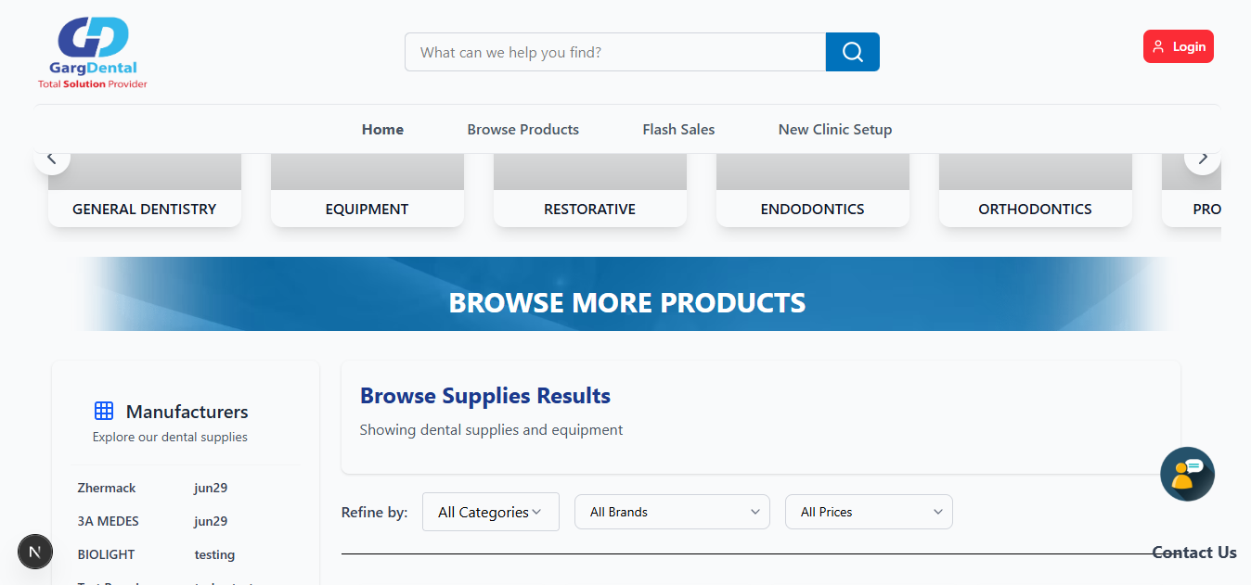
Figure 3: Garg Dental Landing Page
Project 2: NityaGro (Organic Consumer Retail Store)
NityaGro is a high-performance, consumer-oriented retail platform built to optimize the supply line, marketing visibility, and sales distribution of healthy, pure organic agricultural foods and kitchen inventory directly to the end consumer.
- Project Overview and Target Audience: The platform is designed to market premium agro-products such as native ground spices, chemical-free organic jaggery powder, and premium cold-pressed cooking oils. The system serves health-conscious home kitchens and grocery shoppers across metropolitan regions seeking verifiable organic nutrition alternatives.
- Frontend Architecture Layout: The frontend utilizes Server-Side Rendering (SSR) alongside Incremental Static Regeneration (ISR) inside the Next.js compilation engine. This ensures that media-dense showcase elements load almost instantly, while maintaining proper semantic structures optimized for search engine crawlability (SEO).
- Backend API Services: API routes process client cart arrays, parse localized discount values, and compute weight-based delivery costs. The architecture isolates analytical tasks from front-end layout transitions to minimize overall transactional latency.
- Database Management (MySQL & Prisma): The MySQL storage model maintains namic tables covering client registrations, categorization trees, active items, and shipping status indices. Prisma ORM guarantees strict data integrity, automating inventory adjustments upon checkout completion to prevent duplicate orders or inaccurate stock logs.
- User Sessions and Security: User state validation runs through localized JWT handling, ensuring that administrative portals—where store managers alter stock details and modify listing categories—remain strictly inaccessible to unauthorized public accounts.
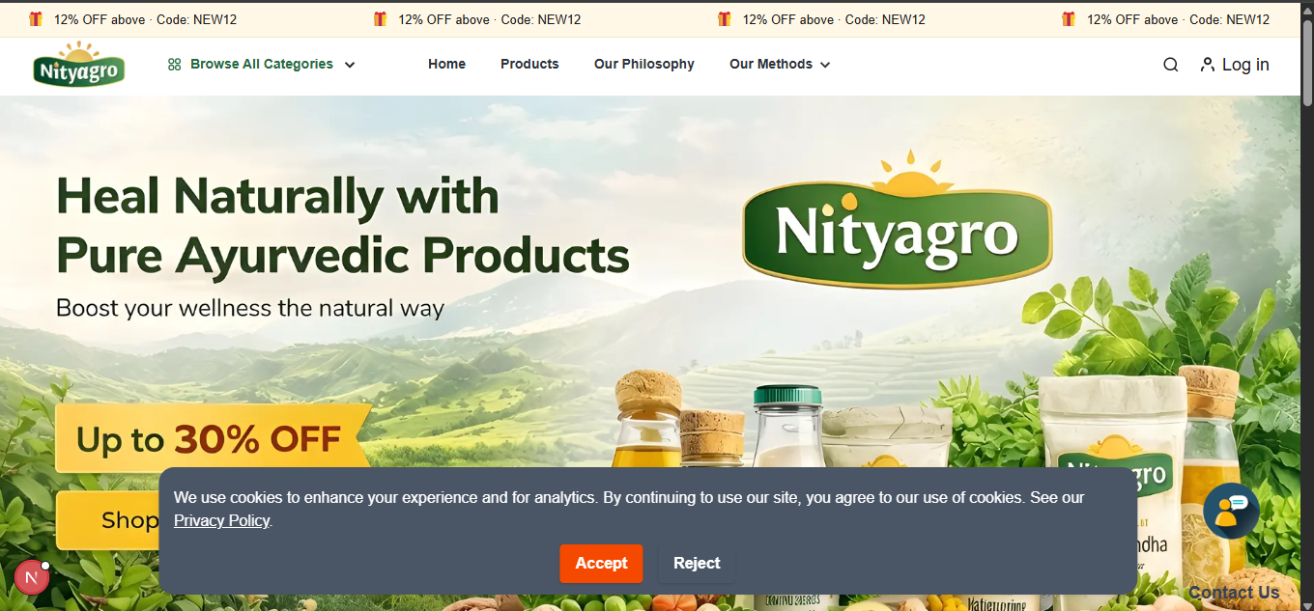
Figure 4: Nityagro Landing Page

4.4. Tasks / Activities Performed
During the internship, I was assigned to work on various tasks and activities related to full-stack web development for the designated e-commerce applications (GargDental and NityaGro). Some of the significant tasks are listed below:
- Frontend Interface Engineering & Responsive Design: The initial task assigned to me was to translate structural system requirements into functional, responsive web layouts using Next.js and Tailwind CSS. I was given explicit project design briefs and wireframe specifications. Using these parameters, I built highly performant, multi-page user interfaces optimized for fluid cross-device navigation across desktop, mobile, and tablet viewports.
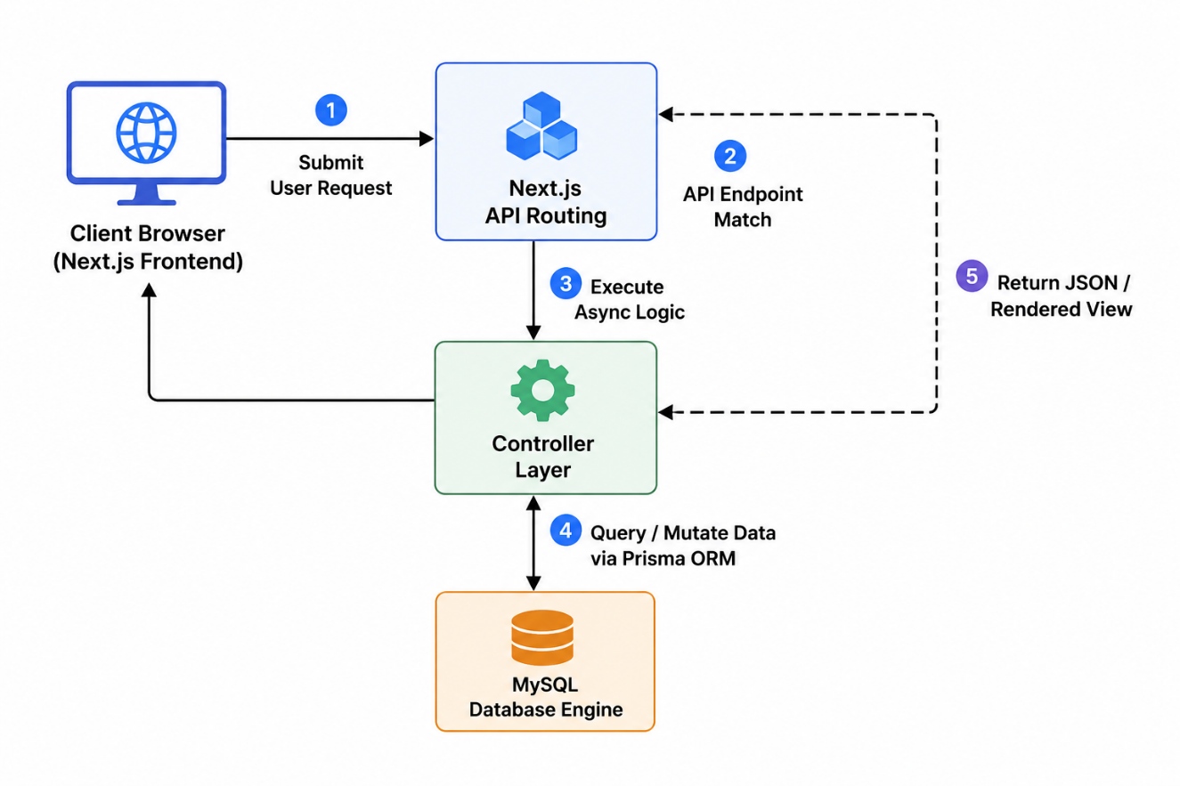
- Next.js Full-Stack Framework Implementation: After designing the visual interfaces, I was tasked with developing the backend architecture utilizing the Next.js framework ecosystem. I engineered secure, decoupled server-side API routes to manage systemic business logic. Adhering to modern asynchronous web architectures, I successfully implemented core CRUD (Create, Read, Update, Delete) operations and deployed an optimized backend API pattern to handle product catalogs, active shopping cart states, and user interactions.
Figure 5: Next.js MVC Design Pattern Architecture
- Relational Database Design & Schema Modeling: For both web applications, I was responsible for designing and organizing the backend data structures. I closely analyzed structural data relationships and designed highly normalized database schemas using a MySQL engine. To bridge the application layer with our relational storage smoothly, I implemented and managed tables, unique constraint rules, and foreign key relations using Prisma ORM, ensuring overall data persistence and eliminating storage anomalies.
- System Verification & Endpoint Testing: I was also held accountable for validating the features and reliability of the developed web applications. I wrote custom testing configurations to check backend API endpoint responses, verification criteria, and secure session route handling. In addition to programmatic validation, I performed meticulous manual edge-case testing to systematically pinpoint, trace, and resolve hidden software bugs.
- Technical Codebase Documentation: Finally, I was responsible for writing comprehensive documentation for the entire codebase and application architecture. I authored clean, developer-centric technical documentation detailing system endpoint structures, the modular directory layout, database schema relationships, and installation processes to assist future development iterations.

CHAPTER 5: CONCLUSION AND LEARNING OUTCOMES

5.1. Conclusion
Completed Module
So far, the development lifecycle for both the GargDental and NityaGro platforms has successfully implemented the core landing interfaces, responsive product catalog showcases, secure multi-role client/admin authentication schemas, active shopping cart states, and the initial centralized administrative dashboards. These components establish the baseline infrastructure of the full-stack applications, ensuring fluid client-side rendering and interactive product parsing for standard users and administrative personnel alike.
Work in Progress
Currently, engineering efforts are centered on refining the Next.js serverless backend API endpoints, optimizing database middleware layers, and tuning complex relational data retrieval patterns. This includes improving transactional security tokens, perfecting input payload validation filters, and ensuring clean, asynchronous operational continuity when data transitions between front-end components and backend architectures.
Remaining Modules
The final stages of the internship development cycle will focus on completing the advanced client and admin user profile customization spaces, integrating localized third-party digital payment gateway networks (such as eSewa), and completing relational MySQL indexing adjustments. These steps are necessary to achieve optimal data query execution times, persistent storage safety, and comprehensive system maintenance.

REFERENCES
Laudon, K. C. (2022). E-Commerce 2022: Business, Technology, Society (17 ed.). Pearson.
Turban, E., Outland, J., King, D., Lee, J. K., Liang, T.-P., & Turban, D. C. (2018). Electronic Commerce 2018: A Managerial and Social Networks Perspective.
Shakya, R., & Shrestha, S. (2021). Digital Wallets and Consumers' Adoption in Nepal: An Empirical Study on Fintech Ecosystems. Journal of Advanced Research in Computer Engineering and Technology, 10(4), 112–120.
eSewa Pvt.Ltd. (2024). Merchant Integration API Specifications and Cryptographic Verification Guidelines. Retrieved July 13, 2025, from https://developer.esewa.com.np
Nepal Rastra Bank. (2022). Payment System Directive: Rules Governing Electronic Transactions and Digital Wallet Service Providers in Nepal. Payment Systems Department, Kathmandu.

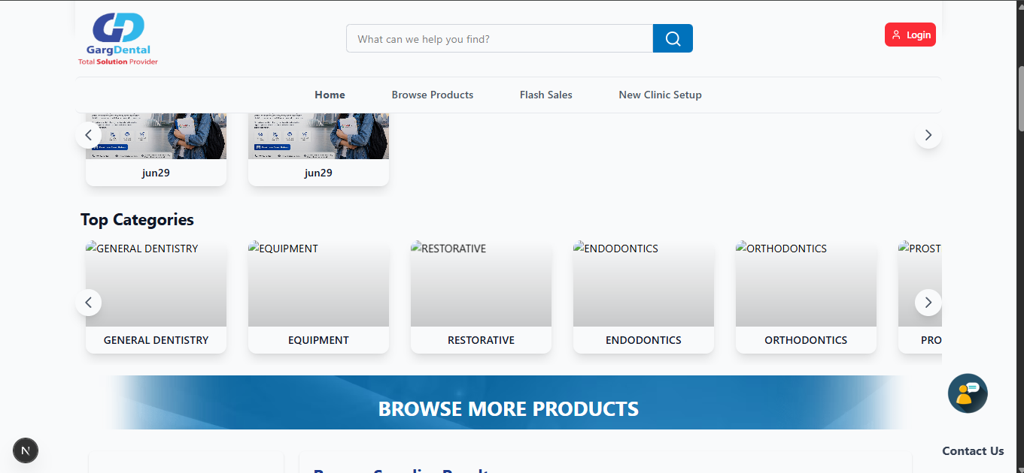
APPENDIX

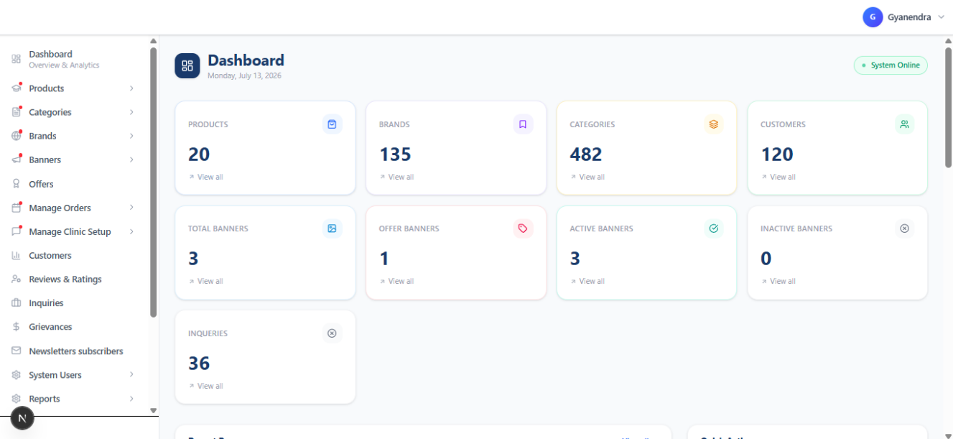
Garg Dental Landing Page
Garg Dental Admin Dashboard

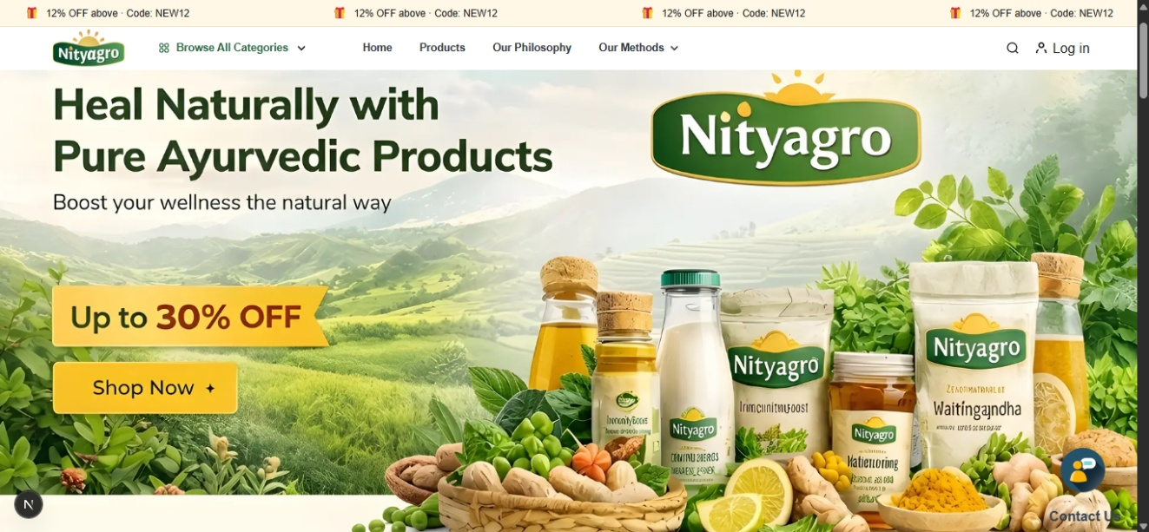
Nityagro Landing Page
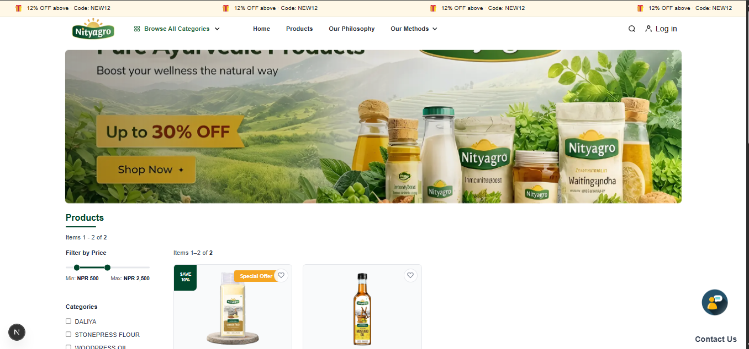
Nityagro Product Page

